Assessment Day Cheatsheet

To succeed at your assessment day you need capability and confidence in the following areas:

Check out our free guides & tick them off as you progress. (Click the links below to go straight to the relevant guide.)
- What to expect at your assessment day
- How to prepare for your assessment day
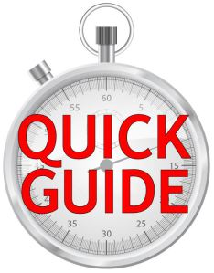
- Group exercises
- Role-plays
- Presentations
- In-tray exercises / E-tray exercises
- Interviews
- Aptitude tests / Logical reasoning tests
- Numerical reasoning tests
- Verbal reasoning tests
- Social etiquette: How to behave at an assessment day
- How to deal with assessment day nerves & anxiety

I hope you find this cheatsheet useful. It’s a great roadmap to follow.

Good luck and speak soon!

Mike Kennedy

PS: If the above links don’t work for you go to this page (where I promise they’ll work!) www.assessmentcentrehq.com/cheatsheet

